**Programming: Software Quality Assurance**

**PROG2070 - Winter 2025 - Section 5**

**Assignment #2**

**Group 9**

Shi Liuyi 8973073

Sarandeep Singh 8910267

Github online address: <https://github.com/SL758/QA_A2_Group9.git>

# Screenshot showing the results of your unit tests being run in Test Explorer

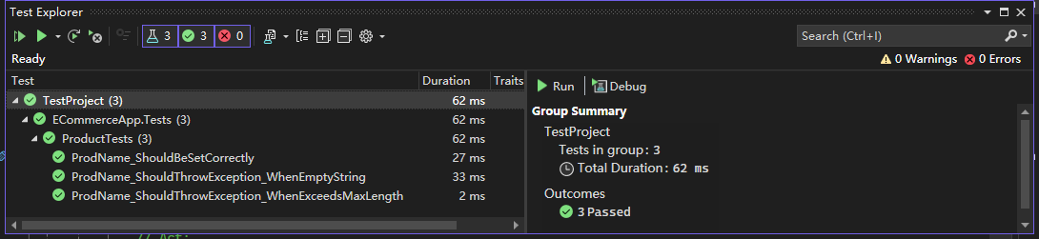

# a screenshot/output of your git repository log.

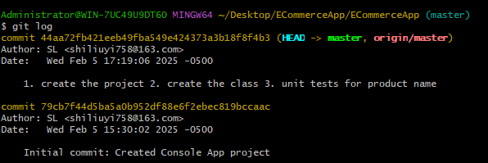

# Copy of Product class source code (The Product.cs in example Figure 1 screenshot)

# Copy of Unit Test class source code (The ProductTest.cs in example Figure 1 screenshot)

* 1. A screen shot of a computer program

     AI-generated content may be incorrect.
  2. A computer screen shot of a program

     AI-generated content may be incorrect.

1. A screen shot of a computer program

   AI-generated content may be incorrect.